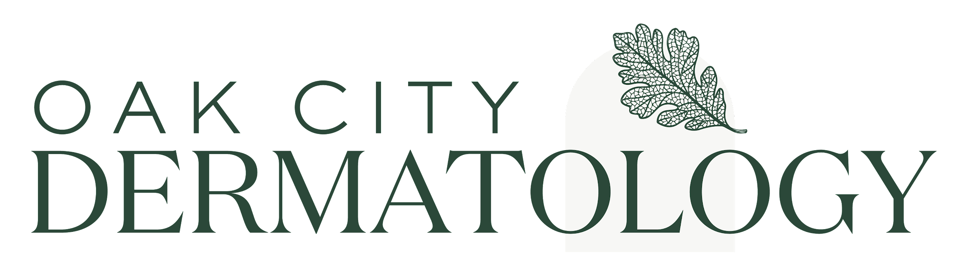

Minor Seen Alone Consent

I, the parent/guardian of this patient, give permission for my child to attend his/her medical appointment alone without my presence, and I authorize treatment for my child in accordance with the office policy of Oak City Dermatology. I understand that office staff will not be able to convey the details of the appointments to me later in the day, rather, it is the responsibility of my child to relay any diagnosis, treatment plan, or prescription(s) back to me as the parent or legal guardian. The minor will also be responsible for providing a history of present illness and any protected health information. I agree to be financially responsible for all charges, copays, and coinsurance incurred in these visits.

Parent/Legal Guardian

